Page Template:
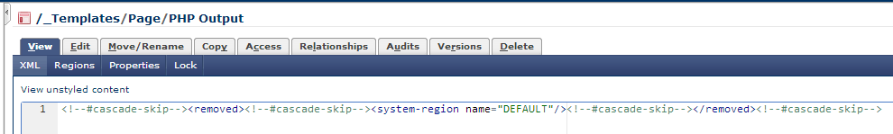
Index Block
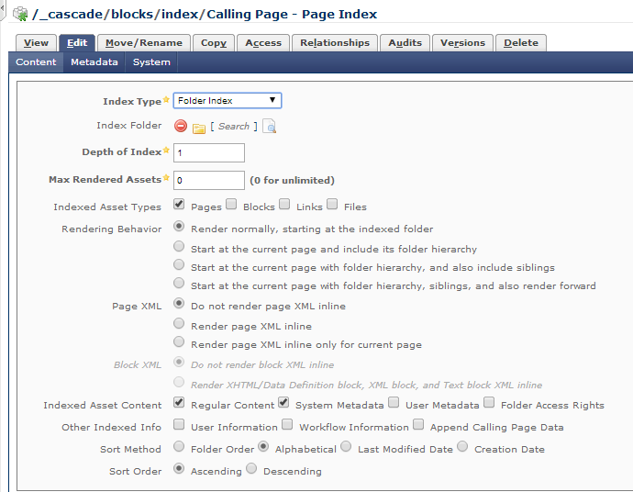

Page:
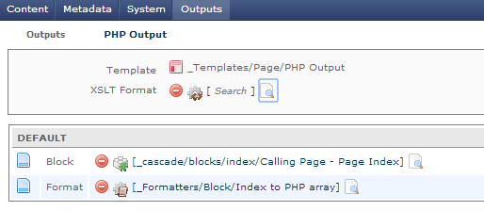
Formatter:
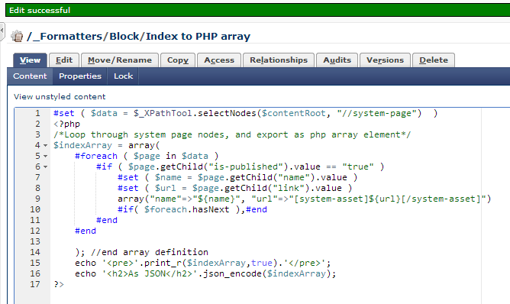
#set ( $data = $_XPathTool.selectNodes($contentRoot, "//system-page") )
<?php
/*Loop through system page nodes, and export as php array element*/
$indexArray = array(
#foreach ( $page in $data )
#if ( $page.getChild("is-published").value == "true" )
#set ( $name = $page.getChild("name").value )
#set ( $url = $page.getChild("link").value )
array("name"=>"${name}", "url"=>"[system-asset]${url}[/system-asset]")
#if( $foreach.hasNext ),#end
#end
#end

); //end array definition
echo '<pre>'.print_r($indexArray,true).'</pre>';
echo '<h2>As JSON</h2>'.json_encode($indexArray);
?>

Output (PHP FILE):
<?php /*Loop through system page nodes, and export as php array element*/
$indexArray = array(
array("name"=>"Anthropology", "url"=>"Anthropology.html")
, array("name"=>"Archaeology and Classical Studies", "url"=>"Archaeology and Classical Studies.html"),
…
, array("name"=>"Women and Gender Studies", "url"=>"Women and Gender Studies.html")

); //end array definition
echo '<pre>'.print_r($indexArray,true).'</pre>';
echo '<h2>As JSON</h2>'.json_encode($indexArray);
?>
Output: HTML

Array
(
[0] => Array
(
[name] => Anthropology
[url] => Anthropology.html
)

[1] => Array
(
[name] => Archaeology and Classical Studies
[url] => Archaeology and Classical Studies.html
)

[2] => Array
(
[name] => Communication Studies
[url] => Communication Studies.html
)

[3] => Array
(
[name] => Cultural Studies
[url] => Cultural Studies.html
)

[4] => Array
(
[name] => English
[url] => English.html
)

[5] => Array
(
[name] => Film Studies
[url] => Film Studies.html
)

[6] => Array
(
[name] => Geography and Environmental Studies
[url] => Geography and Environmental Studies.html
)

[7] => Array
(
[name] => Global Studies
[url] => Global Studies.html
)

[8] => Array
(
[name] => History
[url] => History.html
)

[9] => Array
(
[name] => index
[url] => index.html
)

[10] => Array
(
[name] => index.php
[url] => index.php.php
)

[11] => Array
(
[name] => Languages and Literatures
[url] => Languages and Literatures.html
)

[12] => Array
(
[name] => Medieval Studies
[url] => Medieval Studies.html
)

[13] => Array
(
[name] => North American Studies Program
[url] => North American Studies Program.html
)

[14] => Array
(
[name] => Philosophy
[url] => Philosophy.html
)

[15] => Array
(
[name] => Political Science
[url] => Political Science.html
)

[16] => Array
(
[name] => Religion and Culture
[url] => Religion and Culture.html
)

[17] => Array
(
[name] => Sociology
[url] => Sociology.html
)

[18] => Array
(
[name] => Women and Gender Studies
[url] => Women and Gender Studies.html
)

)

As JSON
[{"name":"Anthropology","url":"Anthropology.html"},{"name":"Archaeology and Classical Studies","url":"Archaeology and Classical Studies.html"},{"name":"Communication Studies","url":"Communication Studies.html"},{"name":"Cultural Studies","url":"Cultural Studies.html"},{"name":"English","url":"English.html"},{"name":"Film Studies","url":"Film Studies.html"},{"name":"Geography and Environmental Studies","url":"Geography and Environmental Studies.html"},{"name":"Global Studies","url":"Global Studies.html"},{"name":"History","url":"History.html"},{"name":"index","url":"index.html"},{"name":"index.php","url":"index.php.php"},{"name":"Languages and Literatures","url":"Languages and Literatures.html"},{"name":"Medieval Studies","url":"Medieval Studies.html"},{"name":"North American Studies Program","url":"North American Studies Program.html"},{"name":"Philosophy","url":"Philosophy.html"},{"name":"Political Science","url":"Political Science.html"},{"name":"Religion and Culture","url":"Religion and Culture.html"},{"name":"Sociology","url":"Sociology.html"},{"name":"Women and Gender Studies","url":"Women and Gender Studies.html"}]

